The IPTC Messaging Matters IECCC Framework (Worksheet)
What is your difficult discussion?

What is the scenario? Who is involved in the conversation?

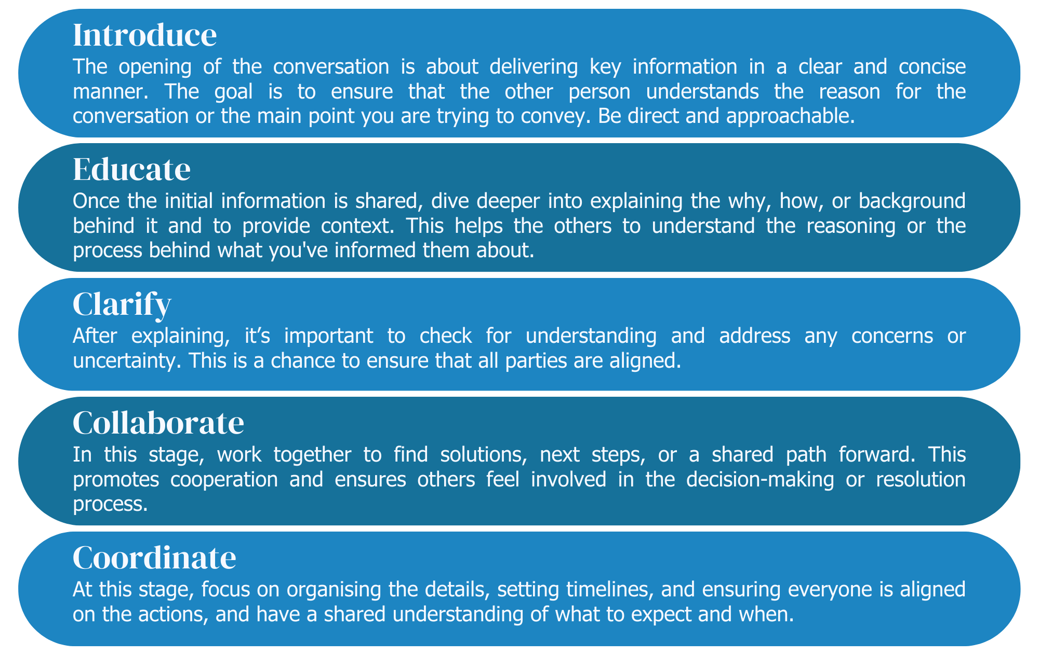
The Framework

Create Your Conversation Roadmap
Introduce
Educate
Clarify
Collaborate
Coordinate

Your contribution matters. Please share your roadmap by scanning and emailing to rheamercado@rtwmatters.org

